MANUFACTURING OF SODIUM HYDROXIDE BY CHLOROALKALI PROCESS

BY-

Abhishek Dhobe-BT15CME021

Chaitanya Ganu-BT15CME025

Mamta Jamgade-BT15CME046

Praneet Lohakare-BT15CME060



Department of Chemical Engineering

**Visvesvaraya National Institute**

**of Technology, Nagpur**

**ACKNOWLEDGEMENT**

It is our esteemed pleasure to present the project report on “Manufacture of Sodium Hydroxide by Chloro Alkali Process”.

We would like to thank Dr. Sachin Mandavgane who helped us a lot in understanding and analysing the process with a deeper understanding and helped us with utter generosity in every possible way.

We would like to express our gratitude to all the people who have helped and supported us throughout our project. Especially we are thankful to all colleagues, in extending their support for our early completion.

This experience shall carry us a long way in the journey of life we are about to embark.

**CERTIFICATE**

This is to certify that this project report contains bonafide work of following students on the topic ***‘Manufacturing of Nitrobenzene by Adiabatic Process’*** under the supervision of

Dr. Sachin Mandavgane.

**Name of Students Roll Numbers**

Abhishek Dhobe BT14CME041

Chaitanya Ganu BT14CME071

Mamta Jamgade BT14CME080

Praneet Lohakare BT14CME016

Dr. Sachin Mandavgane

Department of Chemical Engineering

Visvesvaraya National Institute of Technology

**Index**

1. Sodium Hydroxide………………………………………………………………………………

1. Introduction

2. Physical and Chemicals Properties

3. Uses

4. Hazards

5. Industries producing Nitrobenzene

2. Sodium Chloride…………………………………………………………………………………….

1. Introduction

2. Physical and Chemical Properties

5. Process Description ……………………………………………………

6. Assumptions

7. Storage Tank Design for Water……………………………………………………….

8. Storage Tank Design for Sodium Hydroxide (33%)………………………………………………………………………………………….

9. Storage Tank Design for Sodium Hydroxide (50%)…………………………………………………………………………………………

12. Calculations………………………..

1. Material Balance……………………………..................

2. Mechanism of Reaction………………………………………..

3. Energy Balance………………………………………

13. Flow Rates………………………………………………………………….

14. Agitator Calculations………………………………………………………

15. Piping……………………………………………………………………….

16. Conclusion…………………………………………………………………

17. References…………………………………………………………………..

**LIST OF TABLES**

|  |  |  |
| --- | --- | --- |
| Table Number | Table Name | Page Number |
| 1 | Chemical and Physical Properties of Nitrobenzene | 6 |
| 2 | Chemical and Physical Properties of Benzene | 8 |
| 3 | Chemical and Physical Properties of Nitric Acid | 9 |
| 4 | Chemical and Physical Properties of Sulphuric Acid | 10 |
| 5 | Mass, Volume and Density of Compounds used | 23 |
| 6 | Time taken for each process | 26 |

**LIST OF FIGURES**

|  |  |  |
| --- | --- | --- |
| Figure Number | Figure Name | Page Number |
| 1 | Nitrobenzene production reaction | 24 |
| 2 | Mechanism of nitrobenzene reaction | 24 |
| 3 | Agitator front view and top view | 27 |
| 4 | Packed Bed Distillation Column | 28 |

**Sodium Hydroxide**

1. **Introduction:**

Sodium Hydroxide is an inorganic compound with the chemical formula NaOH. It freezes to give white powder. It is produced on a large scale from NaCl by membrane process. In the laboratory, it is excessively used as an alkali for a wide range of reactions.

**2. Chemical and physical properties:**

|  |  |
| --- | --- |
| **Physical state and appearance** | Flakes(solid) and foggy solution (solution) |
| **Odor** | No odor |
| **Molecular Weight** | 40 g/mole |
| **Color** | Clear, Colorless |
| **Boiling Point** | 140°C (284°F) |
| **Melting Point** | 12°C (53.6°F) |
| **Specific Gravity** | 1.53 (Water = 1) |
| **Vapor Pressure** | 1.5 mm of Hg (@ 20°C) |
| **Vapor Density** | 0.62 (Air = 1) |
| **Dispersion Properties** | See solubility in water. |
| **Solubility** | Easily soluble in cold water. |

TABLE 1: Chemical and Physical Properties of NaOH

**3. Uses:**

1. Approximately 35% of NaOH is consumed in the production of aluminum.

2. It is used for the scrubbing of gases from major industries before releasing it to the environment.

3. It is widely used in the manufacturing of soaps and detergents from fatty acids.

4. Sodium hydroxide is widely used for the production of a wide range of compounds such as ammonia, cresols, etc.as a strong alkali.

5. One of the most important applications is in the pulp and paper industry.

**4. Hazards:**

1. Sodium Hydroxide is highly corrosive and extremely harmful to the skin.

2. Liquid caustic soda can react violently with strong acids. Contact with certain metals can

produce hydrogen.

3. Liquid or spray mist may produce tissue damage particularly on mucous membranes of eyes, mouth and respiratory tract. Skin contact may produce burns. Inhalation of the spray mist may produce severe irritation of respiratory tract, characterized by coughing, choking, or shortness of breath. Severe over-exposure can result in death. Inflammation of the eye is characterized by redness, watering, and itching. Skin inflammation is characterized by itching, scaling, reddening, or, occasionally, blistering.

4. Sodium hydroxide reacts to form explosive products with ammonia + silver nitrate. Benzene extract of allyl benzenesulfonate prepared from allyl alcohol, and benzene sulfonyl chloride in presence of aquesous sodium hydroxide, under vacuum distillation, residue darkened and exploded. Sodium Hydroxde + impure tetrahydrofuran, which can contain peroxides, can cause serious explosions. Dry mixtures of sodium hydroxide and sodium tetrahydroborate liberate hydrogen explosively at 230-270 deg. C. Sodium Hydroxide reacts with sodium salt of trichlorophenol + methyl alcohol + trichlorobenzene + heat to cause an explosion. (Sodium hydroxide).

**5. Industries producing nitrobenzene:**

1. Occidental Chemical Corporation, USA ,

2. NALCO(Andhra Pradesh),

3. Hindustan Aluminium Company, etc.

**Sodium Chloride**

**1. Introduction:**

Sodium chloride is an important chemical compound with the chemical formula NaCl. Its molecule is composed of Na+ and Cl- ions. Thus it is an ionic compound which is the salt formed due to neutralization. Sodium Chloride is naturally found in sea water and that is the primary source of it. It is one of the most abundant salts in the world. It is white in color. Forms crystals that are white in color and is salty to taste. It is an odorless compound. It is mainly used as an additive to food for its salty taste. It is used on a large scale for the production of NaOH in the form of brine solution.

**Process Flow Diagram**

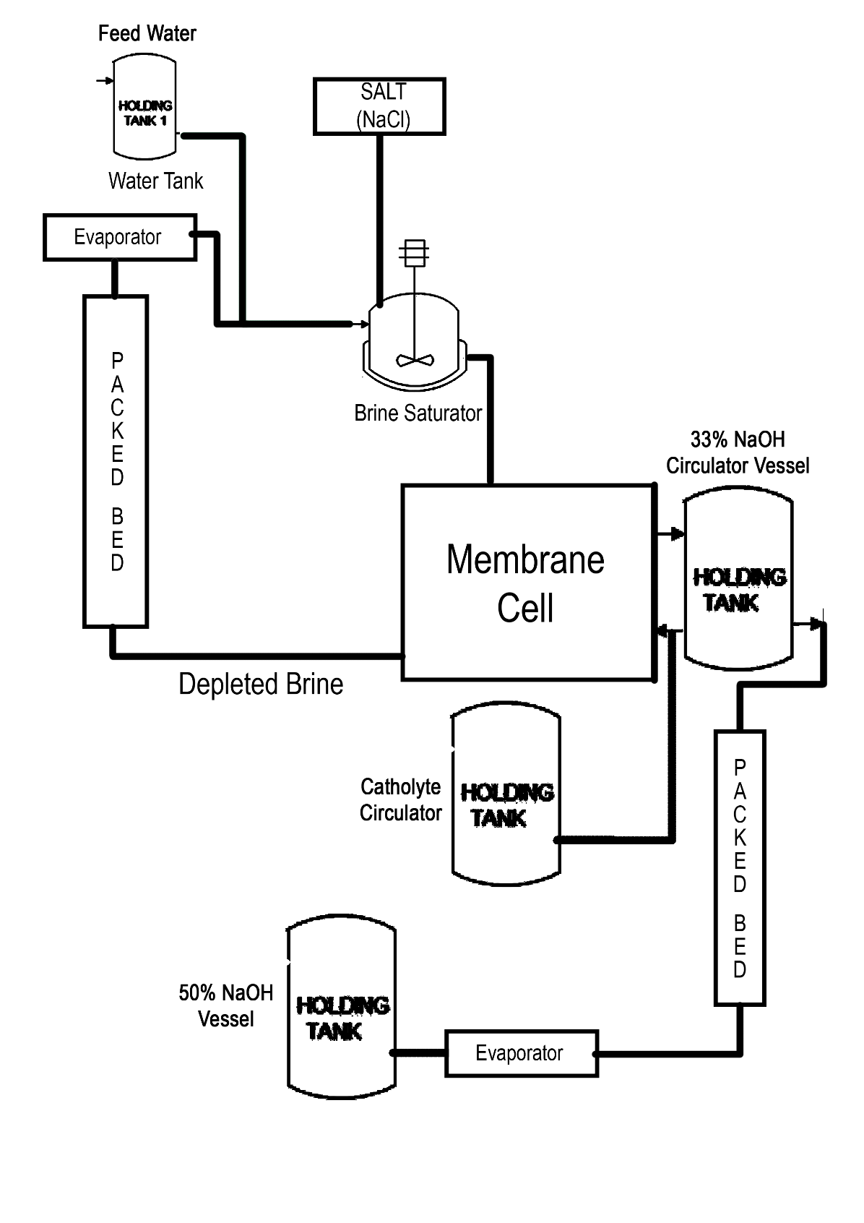

**2. Chemical and physical properties:**

|  |  |
| --- | --- |
| **Physical state and appearance** | Clear Liquid |
| **Odor** | Odorless |
| **Molecular Weight** | 58.5 g/mole |
| **Color** | White |
| **Boiling Point** | N/A |
| **Melting Point** | N/A |
| **Critical Temperature** | N/A |
| **Specific Gravity** | 1.0-1.2 |
| **Vapor Pressure** | N/A |
| **Vapor Density** | N/A |
| **Water/Oil Dist. Coeff** | See solubility for water |
| **Solubility:** | Highly soluble in water. |

Table 2: Chemical and Physical Properties of Sodium Chloride

**Process description**

Caustic soda is manufactured commercially by the electrolysis of a sodium chloride (NaCl) solution. With a typical batch process, the reactor is charged with benzene at a temperature of 25 degrees. It is subjected to membrane process. The concentrated sodium hydroxide formed is then evaporated and a part of it is fed again into the half-cell to maintain the concentration. The purified sodium hydroxide is then taken to a storage tank. Today, sodium hydroxide is made by a continuous process, but the sequence of operations is basically the same as for batch processing. However, for a given rate of production, the size of the reactors is much smaller in a continuous process.

**Assumptions**

1.1000 kg per hour of 50% sodium hydroxide solution.

2. 55% efficiency (overall industrial efficiency 95%)

3. 20 tonnes of caustic soda (50%) per day

4. Rate of evaporation =515.15 kg of water evaporated per hour

5. No of working days in a year = 300 days

6. Service Life:

* Anode coating: 8 yrs.
* Cathode coating:4yrs
* Membranes: 4yres
* Gaskets: 4yrs
* Compartments: 20 yrs.
* Active area per element: 2.72 m2

7. Electrolyte density is constant throughout.

**Storage tank design for sodium hydroxide (50%)**

**Storage conditions:**

1. **Temperature**: Sodium hydroxide is stored at room temperature i.e. 25-30 degree Celsius as it does not react at room temperature.

2. **Pressure**: Pressure at which sodium hydroxide is stored depends on height of liquid. It is calculated later in the calculations.

3. **Material of storage tank**: Sodium hydroxide is an extremely corrosive compound. Due to its low reactivity, we generally use stainless steel of grade 302L/I as the material of the storage tank for this solution. To further ensure that the vessel is not harmed due to corrosion, the cylinder is provided with a PVC lining from inside.

**Assumptions:**

1 .Shape of the tank is considered to be cylindrical.

2. Height of the liquid (L) = one and half times of diameter of the storage tank (D)

i.e. L/D = 1.5

3. Since it is the final product storage vessel, we make it such that it can accommodate 2 days of Sodium hydroxide production.

**CALCULATIONS:**

Mass of sodium hydroxide solution (50%), m = 1000 kg/hr.

For 2 days at 20 hrs/day=40,000kg

Density of sodium hydroxide, ρ **=** 1500kg/m3

Acceleration due to gravity, g =9.81 m/s2

1) Volume of NaOH, V = m/ρ = 40,000kg/1500 kg/m3 = 28.667m3

2) Volume of tank should be 20-30% more than that of volume of chemical.

Volume of tank, Vt = V + 20 % of V

= 1.2 V

= 1.2 * 28.667m3

= 32 m3

3) Volume of Cylinder = V h

= ×1.5D

D =

D=3.006m

L = 1.5×D= 1.5 × 3.238 = 4.509 m

4) Vapour Pressure (From MSDS) = P1 = 200 Pa

Volumetric Pressure = P = ρgh = 1500×9.81×4.509 = 66349.935 Pa

Poperating = P1 + P = 200+ 66349.935 = 66549.918 Pa

Pactual = Poperating×1.2 = 66549.91×1.2 = 79859.90 Pa

5) Thickness of shell of storage tank, Ts:

P = Pressure of storage tank

J = Joint efficiency = 0.85

C = Corrosion allowance, generally = 3 mm

The strength of material used (stainless steel) is given by σ whose value is 860 MPa.

Thickness of Cylindrical part = + 3×10-3= +3×10-3

= 3.16410-3 metres

**Note**: For safe storage, the pressure should be considered double the value of pressure during calculation.

Ts = 3.164 mm

6) Thickness of roof, Tr:

= + 3 ×10-3 = + 3 ×10-3

=0.00300049m

Tr = 3.000mm

7) Thickness of bottom, Tb:

A = D + 0.15

Tb = [(3* ρ*H*A2) / 4* σ)]1/2

Tb = 7.664 mm

**Pressure Vessels**

|  |  |  |  |  |  |  |  |  |
| --- | --- | --- | --- | --- | --- | --- | --- | --- |
| **Compound** | **Material** | **Capacity**  **(per hour)** | **Diameter** | **Height** | **Thickness of Walls** | **Thickness of ends** | **No. of Inlets** | **No. of Outlets** |
| Feed Water | Stainless  Steel | 2081.249kg | 3.46m | 5.19m | 3.15mm | 3.182mm | 1 | 1 |
| NaOH(30%) | Stainless  Steel | 1364kg | 1.21m | 1.81m | 3.0265mm | 3.0318mm | 1 | 2 |
| Catholyte Water | Stainless  Steel | 151.51kg | 3.31m | 4.965m | 3.1348mm | 3.17mm | 1 | 1 |
| NaOH(50%) | Stainless Steel | 1000kg | 3.006m | 4.509m | 3.164mm | 3.0000mm | 1 | 1 |

Table 3: Details of Pressure vessels utilised.

**Calculations**

|  |  |  |  |
| --- | --- | --- | --- |
| **Compound** | **Amount(kg)** | **Density(Kg/m3)** | **Volume(m3)** |
| Sodium Chlorine | 14625 | 1010 | 14.4801 |
| Sodium Hydroxide | 10000 | 1500 | 6.667 |

Table 4: Mass, Volume and Density of compounds used

**Material balance:**

No of moles of NaOH being produced over day=10000/40=250kmols

Yield=Amount of desirable product =100%

Amount of reactant used

Single pass conversion: 55% of NaCl is converted to NaOH.

Amount of NaCl used for reaction= kg/single pass

No. of moles of NaCl used for reaction= kmols

1 mole of NaOH to be produced 1 mole of NaCl has to react.

So, 12.5 kmoles of NaCl is reacting.

No of moles of NaCl in product stream= 0

Density of NaCl = 1.01 g/l

**Flow rates**

**1. Agitator**

Inlet flow for depleted brine = 2301.1365 kg/hr

Inlet flow of water = 2081.2499 kg/hr

Outlet flow of saturated brine = 5113.6364 kg/hr

Inlet flow of salt = 731.25 kg/hr

**Agitator calculations**



Figure 3: Agitator front view and top view

Mass of Brine solution = 5113.225kg

Density of Brine solution = 1010kg/m3

Volume of brine =Vbrine = 5.06 m3

Volume of tank =Vtank = 5.06/0.85 = 5.95m3

Diameter of tank = D = = 1.677m

Length of tank = L = 1.83m

DA = D/3 = 0.55m

H= L/3= 0.61m

N= 2rps

Viscosity = µ = 1.1cP

**Reynold’s number**:

> 10000

**Power Consumption:**

**Packed bed cooling tower**



Length of pack bed = 13.94m

Diameter of packed bed distillation column = 6.92 m

Packing material = Raschig rings

έ (voidage) = 0.4

Sphericity = 1

Dimensions of Rachig Rings = D = 3 mm

Density of packing material = 2600 kg/m3

Density of di-ethylene glycol vapours @ 80.1 degree Celsius @ 0.5 atm = 1.118 kg/m3

Figure 4: Packed Bed Distillation Column

**Piping**

1,2,3,4) Flow rate = 0.035m3/s

Area = 0.035/2 = 0.0175m2

Pipe diameter = √ (A*4)/π = √ (0.0175*4)/π = 0.15m

5) Flow rate = 0.027m3/s

Area = 0.027/2 = 0.0135m2

Pipe diameter = √ (A*4)/π = √ (0.0135*4)/π = 0.13m

6) Flow rate = 0.011m3/s

Area = 0.011/2 = 0.0055m2

Pipe diameter = √ (A*4)/π = √ (0.0055*4)/π = 0.083m

7) Flow rate = 0.016m3/s

Area = 0.016/2 = 0.008m2

Pipe diameter = √ (A*4)/π = √ (0.008*4)/π = 0.1m

8) Flow rate = 0.023m3/s

Area = 0.023/2 = 0.0125m2

Pipe diameter = √ (A*4)/π = √ (0.0125*4)/π = 0.12m

All pipes are made of standard steel.

**Conclusion**

Moles of Benzene supplied = 877.23 kmoles

Moles of HNO3 supplied = 5538.07 kmoles

Moles of H2SO4 supplied = 3560.19 kmoles

Moles of Nitrobenzene formed = 487.8/batch

**References**

1.http://www.umich.edu/~elements/fogler%26gurmen/html/01chap/html/CD-Ch01-NitroBenzene.pdf

2.https://en.wikipedia.org/wiki/Nitrobenzene

3.https://en.wikipedia.org/wiki/Benzene

4.http://www.sciencelab.com/msds.php?msdsId=9925146

5.http://www.sciencelab.com/msds.php?msdsId=9926241

6.http://www.sciencelab.com/msds.php?msdsId=9927339

7.http://www.sciencelab.com/msds.php?msdsId=9926260

8.http://encyclopedia.che.engin.umich.edu/Pages/SeparationsChemical/Absorbers/Absorber

9. Unit Operations of Chemical Engineering by McCabe and Smith

10. Dryden’s Outlines of Chemical Technology

11. Fluid Mechanics in Chemical Engineering by Noel de Nevers